LIBRARY MANAGEMENT
SYSTEM
******
Manual Guide
HOME
Start running the Application, the form Login will appear:
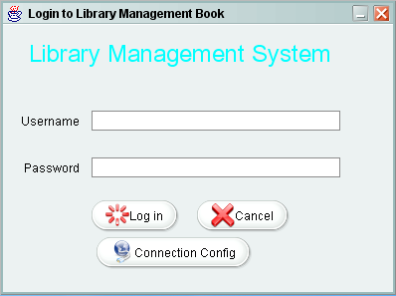
On the first login, you will need to change the Connection config for system by clicking to ‘Connection Config’
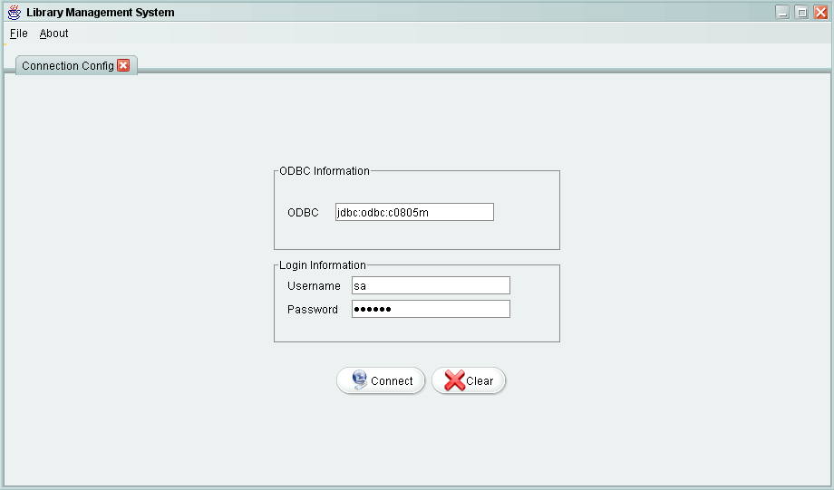
Then you have to type ODBC,and username ,password to login to SQL Server ,click ‘Connect’ button to connect. If it appears: “Successful Connection” the login form will appear again and you have to type Username and password.
After logging on to application successfully. You logon as User, the tasks for User will be displayed with application.
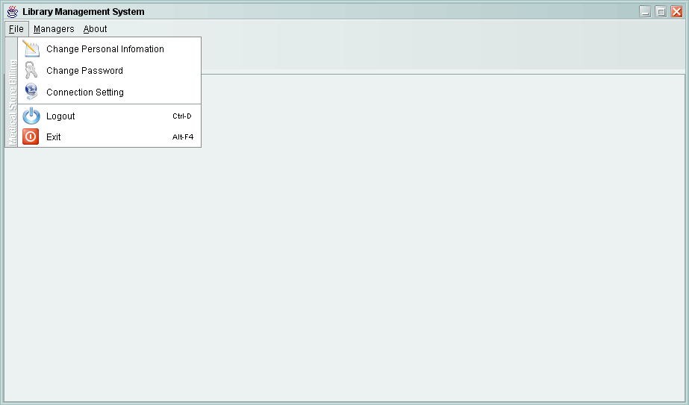
After Login you can Change your personal information and password
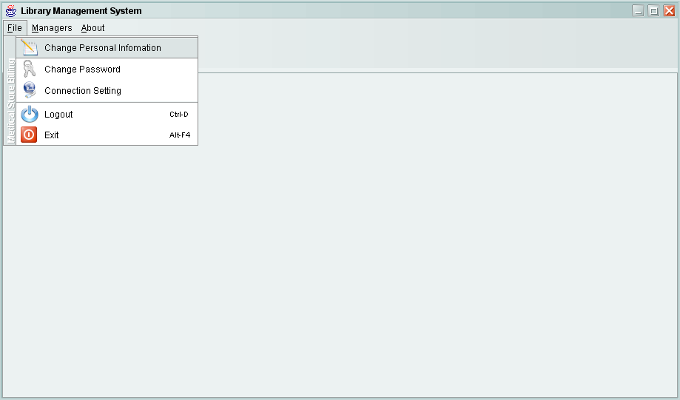
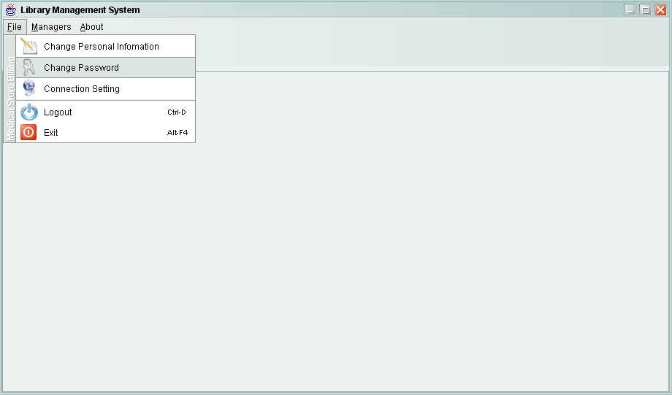
User Management
In User Management
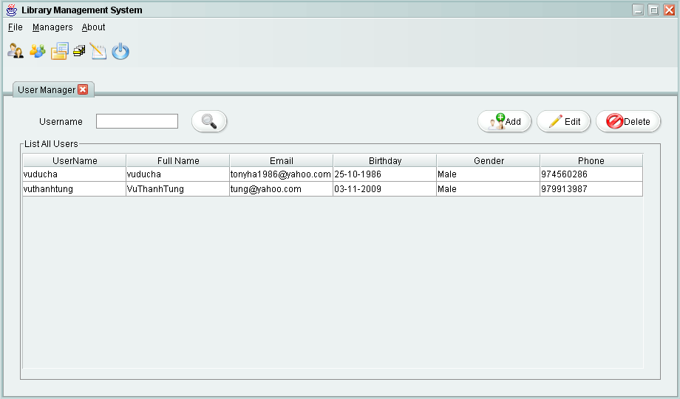
You can add new User by clicking 'Add ' button.
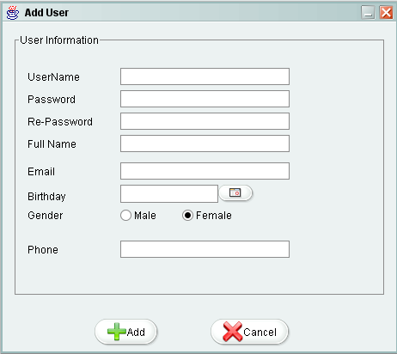
You can edit User by clicking 'Edit ' button.
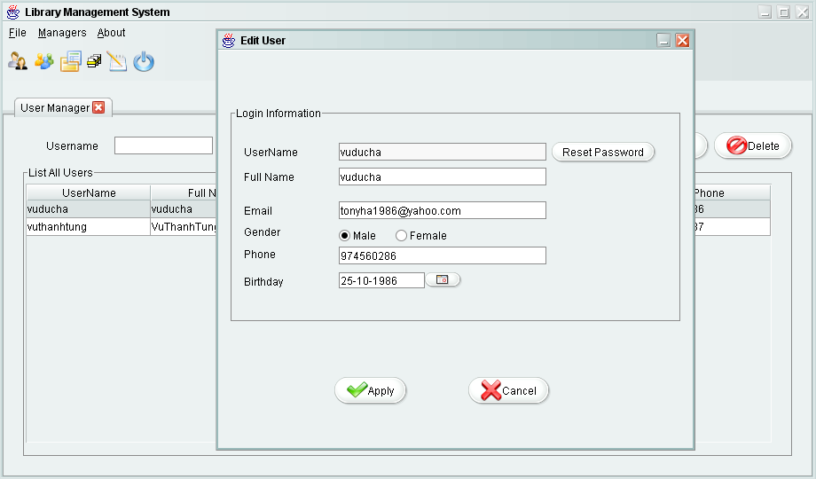
Employee Management
In Employee Management
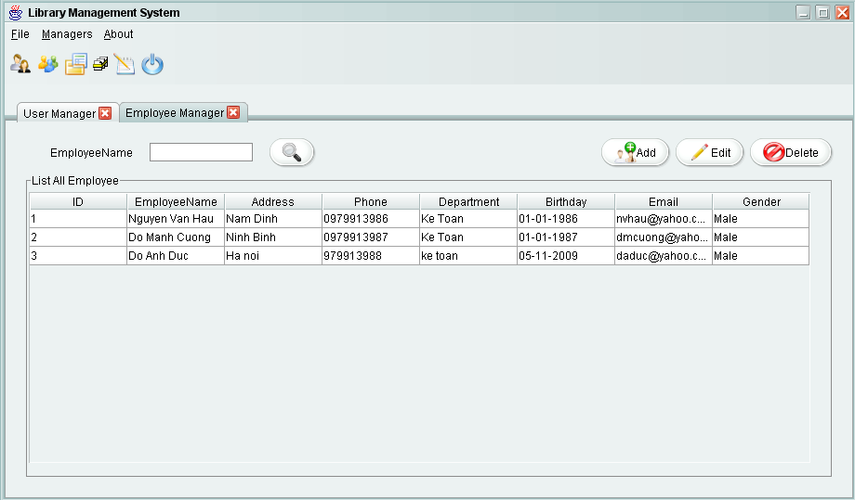

You can add new Employee by clicking 'Add ' button.

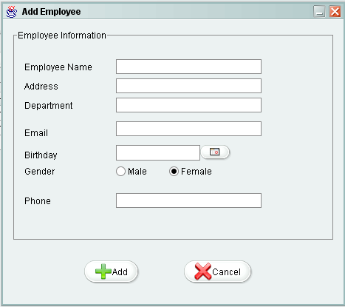

You can edit Employee by clicking 'Edit ' button.
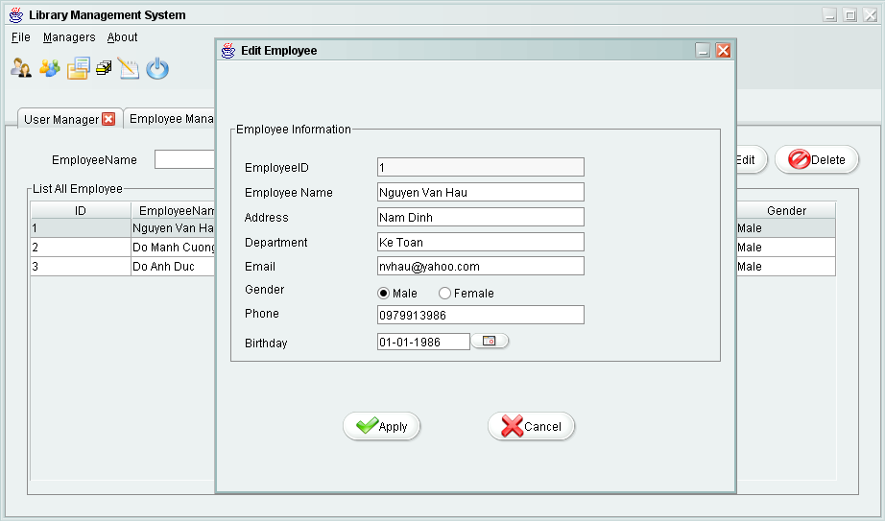
Book Management

In Book Management
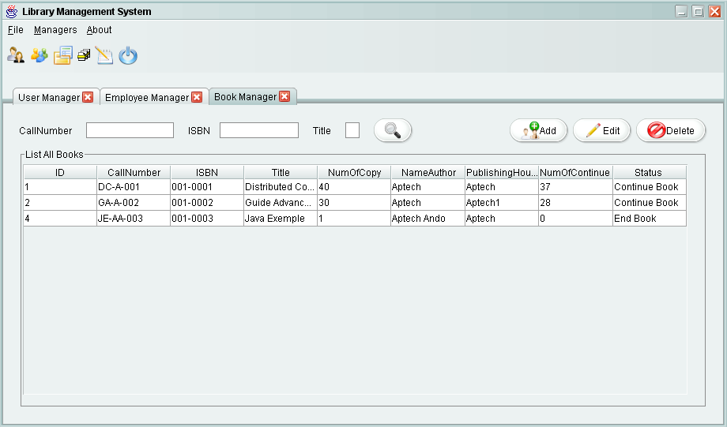
You can add new Book by clicking 'Add ' button.
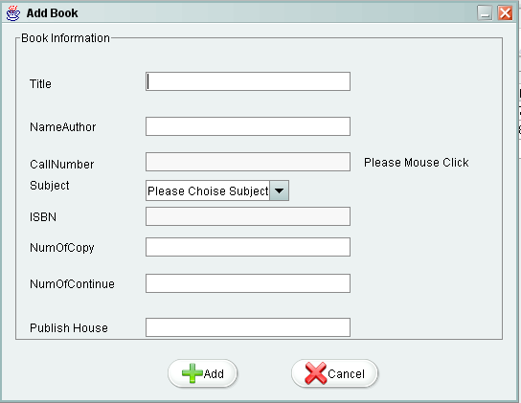

You can edit Book by clicking 'Edit ' button.
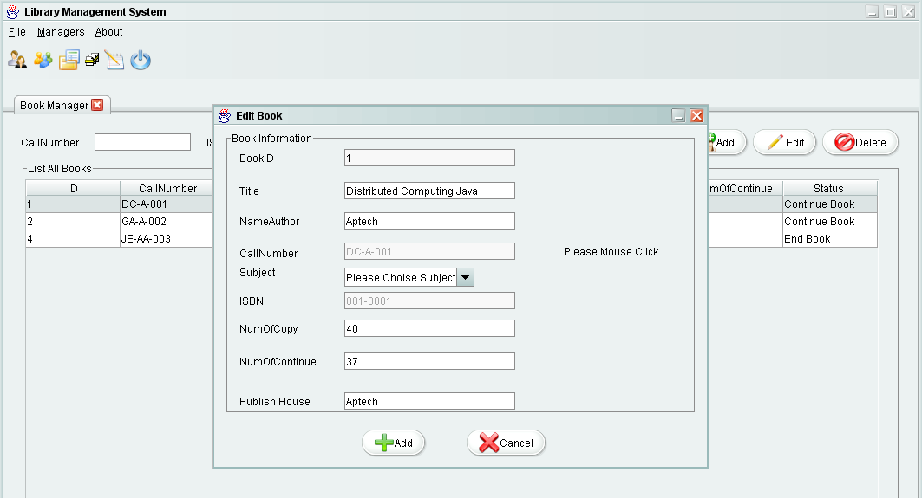

Borrow Management
In Borrow Management

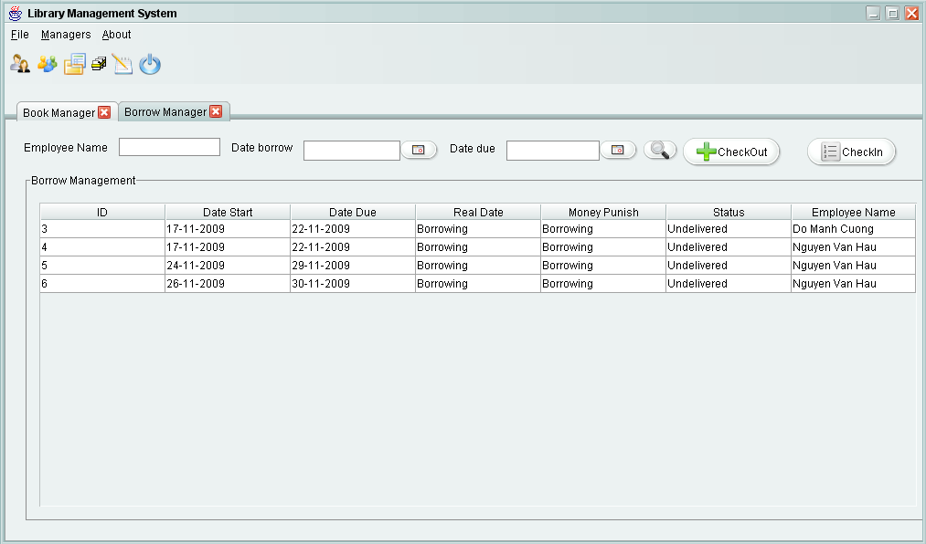
CheckOut Book.
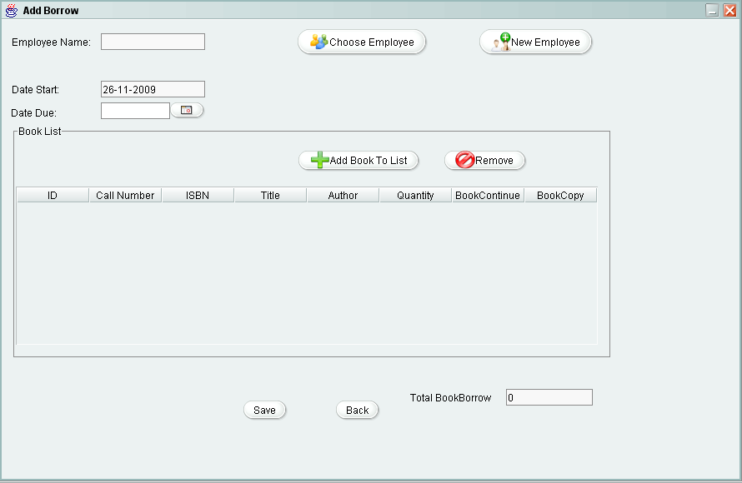
Whem you click AddBookToList.
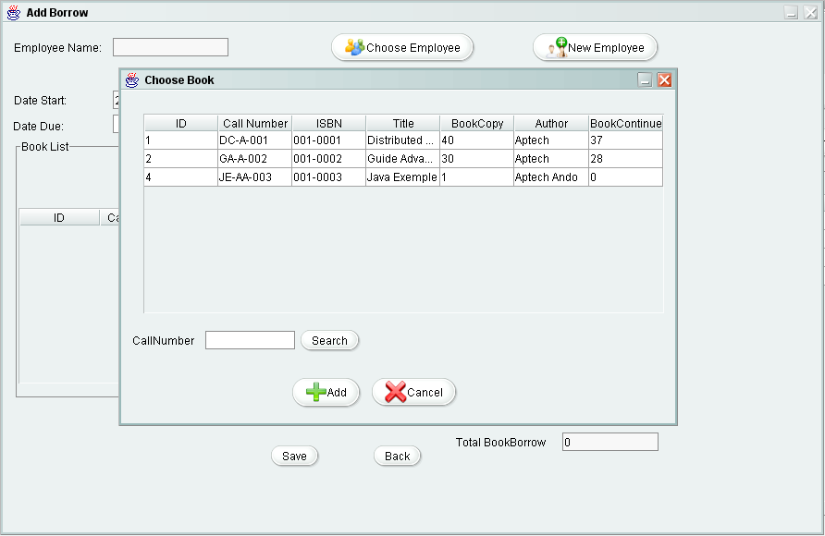
CheckIn Book.
